**Android Questions**

1. Write an application to create a splash screen.
2. Create table Student (roll no, name, address, percentage).

Create Application for performing the following operation on the table.

(Using SQLite database).

i] Insert record of 5 new student details.

ii] Show all the student details.

//Refer Studentdb Program 18

1. Create an application that allows the user to enter a number in the textbox. Check whether the number in the textbox is Prime or not. Print the message accordingly in the label control.

//xmlfile

<?xml version="1.0" encoding="utf-8"?>

<LinearLayout xmlns:android="http://schemas.android.com/apk/res/android"

android:layout_width="match_parent"

android:layout_height="match_parent"

android:orientation="vertical"

android:padding="16dp"

android:gravity="center">

<EditText

android:id="@+id/numberInput"

android:layout_width="wrap_content"

android:layout_height="wrap_content"

android:hint="Enter a number"

android:inputType="number"

android:layout_marginBottom="16dp"

android:gravity="center"

android:minWidth="200dp" />

<Button

android:id="@+id/checkButton"

android:layout_width="wrap_content"

android:layout_height="wrap_content"

android:text="Check if Prime" />

<TextView

android:id="@+id/resultLabel"

android:layout_width="wrap_content"

android:layout_height="wrap_content"

android:text=""

android:textSize="18sp"

android:layout_marginTop="16dp" />

</LinearLayout>

//MainActivity

package com.example.primechecker;

import android.os.Bundle;

import android.view.View;

import android.widget.Button;

import android.widget.EditText;

import android.widget.TextView;

import androidx.appcompat.app.AppCompatActivity;

public class MainActivity extends AppCompatActivity {

private EditText numberInput;

private Button checkButton;

private TextView resultLabel;

@Override

protected void onCreate(Bundle savedInstanceState) {

super.onCreate(savedInstanceState);

setContentView(R.layout.activity_main);

numberInput = findViewById(R.id.numberInput);

checkButton = findViewById(R.id.checkButton);

resultLabel = findViewById(R.id.resultLabel);

checkButton.setOnClickListener(new View.OnClickListener() {

@Override

public void onClick(View v) {

String input = numberInput.getText().toString();

if (!input.isEmpty()) {

int number = Integer.parseInt(input);

if (isPrime(number)) {

resultLabel.setText(number + " is a Prime number.");

} else {

resultLabel.setText(number + " is not a Prime number.");

}

} else {

resultLabel.setText("Please enter a number.");

}

}

});

}

// Method to check if a number is prime

private boolean isPrime(int num) {

if (num <= 1) return false;

for (int i = 2; i <= Math.sqrt(num); i++) {

if (num % i == 0) return false;

}

return true;

}

}

//output

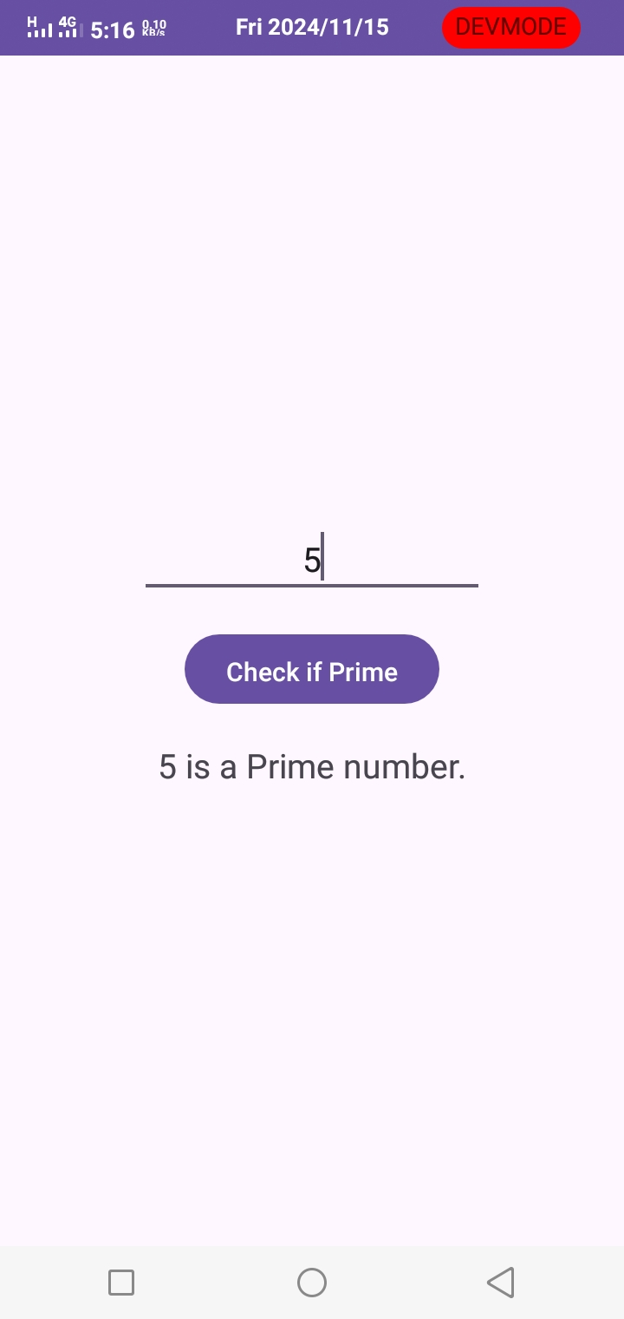

1. Java Android Program to perform all arithmetic Operations using Calculators.

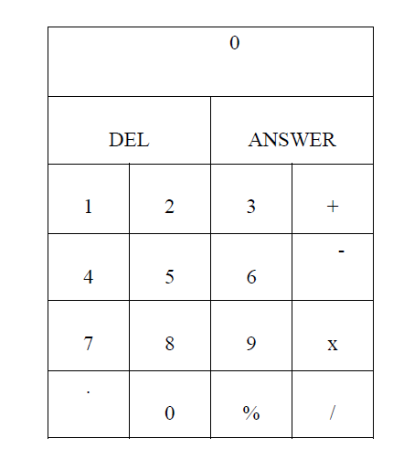

//Refer calculator Program 22

1. Construct image switcher using setFactory().

//XMLFile

<?xml version="1.0" encoding="utf-8"?>

<LinearLayout xmlns:android="http://schemas.android.com/apk/res/android"

android:layout_width="match_parent"

android:layout_height="match_parent"

android:orientation="vertical"

android:padding="16dp"

android:gravity="center">

<ImageSwitcher

android:id="@+id/imageSwitcher"

android:layout_width="300dp"

android:layout_height="300dp"

android:layout_gravity="center"

android:background="#ddd" />

<LinearLayout

android:layout_width="wrap_content"

android:layout_height="wrap_content"

android:orientation="horizontal"

android:layout_gravity="center"

android:paddingTop="16dp">

<Button

android:id="@+id/prevButton"

android:layout_width="wrap_content"

android:layout_height="wrap_content"

android:text="Previous" />

<Button

android:id="@+id/nextButton"

android:layout_width="wrap_content"

android:layout_height="wrap_content"

android:text="Next"

android:layout_marginStart="16dp"/>

</LinearLayout>

</LinearLayout>

//MainActivity

package com.example.imageswitcher;

import android.os.Bundle;

import android.view.View;

import android.view.ViewGroup;

import android.widget.Button;

import android.widget.ImageSwitcher;

import android.widget.ImageView;

import android.widget.ViewSwitcher;

import androidx.appcompat.app.AppCompatActivity;

public class MainActivity extends AppCompatActivity {

private ImageSwitcher imageSwitcher;

private Button prevButton, nextButton;

// Array of images to switch between

private int[] images = {R.drawable.image1, R.drawable.image2, R.drawable.image3, R.drawable.image4};

private int currentIndex = 0;

@Override

protected void onCreate(Bundle savedInstanceState) {

super.onCreate(savedInstanceState);

setContentView(R.layout.activity_main);

imageSwitcher = findViewById(R.id.imageSwitcher);

prevButton = findViewById(R.id.prevButton);

nextButton = findViewById(R.id.nextButton);

// Set factory to create ImageView for ImageSwitcher

imageSwitcher.setFactory(new ViewSwitcher.ViewFactory() {

@Override

public View makeView() {

ImageView imageView = new ImageView(MainActivity.this);

imageView.setLayoutParams(new ImageSwitcher.LayoutParams(

ViewGroup.LayoutParams.MATCH_PARENT,

ViewGroup.LayoutParams.MATCH_PARENT));

imageView.setScaleType(ImageView.ScaleType.FIT_CENTER);

return imageView;

}

});

// Set the initial image

imageSwitcher.setImageResource(images[currentIndex]);

// Set listeners for navigation buttons

prevButton.setOnClickListener(new View.OnClickListener() {

@Override

public void onClick(View v) {

currentIndex = (currentIndex - 1 + images.length) % images.length;

imageSwitcher.setImageResource(images[currentIndex]);

}

});

nextButton.setOnClickListener(new View.OnClickListener() {

@Override

public void onClick(View v) {

currentIndex = (currentIndex + 1) % images.length;

imageSwitcher.setImageResource(images[currentIndex]);

}

});

}

}

//output

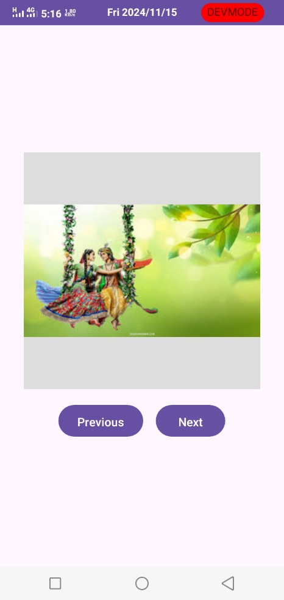

1. Create table Employee (E_id, name, address, pho_no). Create Application for performing the following operation on the table. (Using SQLite database).
2. Insert record of 5 new Employees.
3. Show all the details of Employee.

//Refer Studentdb Program 18

1. Create a Application which shows Life Cycle of Activity.

//XMLFile

<?xml version="1.0" encoding="utf-8"?>

<RelativeLayout xmlns:android="http://schemas.android.com/apk/res/android"

android:layout_width="match_parent"

android:layout_height="match_parent"

android:padding="16dp">

<TextView

android:id="@+id/lifecycleStatus"

android:layout_width="wrap_content"

android:layout_height="wrap_content"

android:text="Lifecycle State"

android:textSize="18sp"

android:layout_centerHorizontal="true"

android:layout_marginTop="50dp" />

<Button

android:id="@+id/lifecycleBtn"

android:layout_width="wrap_content"

android:layout_height="wrap_content"

android:text="Click Me"

android:layout_centerInParent="true" />

</RelativeLayout>

//MainActivity

package com.example.activitylifecycle;

import android.os.Bundle;

import android.util.Log;

import android.widget.Button;

import android.widget.TextView;

import android.widget.Toast;

import androidx.appcompat.app.AppCompatActivity;

public class MainActivity extends AppCompatActivity {

private TextView lifecycleStatus;

private Button lifecycleBtn;

@Override

protected void onCreate(Bundle savedInstanceState) {

super.onCreate(savedInstanceState);

setContentView(R.layout.activity_main);

// Initialize views

lifecycleStatus = findViewById(R.id.lifecycleStatus);

lifecycleBtn = findViewById(R.id.lifecycleBtn);

// Set initial state text

lifecycleStatus.setText("Activity Created");

// Set button click listener

lifecycleBtn.setOnClickListener(view ->

Toast.makeText(MainActivity.this, "Button Clicked!", Toast.LENGTH_SHORT).show()

);

// Log and show the state

showLifecycleState("onCreate");

}

@Override

protected void onStart() {

super.onStart();

showLifecycleState("onStart");

}

@Override

protected void onResume() {

super.onResume();

showLifecycleState("onResume");

}

@Override

protected void onPause() {

super.onPause();

showLifecycleState("onPause");

}

@Override

protected void onStop() {

super.onStop();

showLifecycleState("onStop");

}

@Override

protected void onRestart() {

super.onRestart();

showLifecycleState("onRestart");

}

@Override

protected void onDestroy() {

super.onDestroy();

showLifecycleState("onDestroy");

}

private void showLifecycleState(String state) {

// Update TextView with the current lifecycle state

lifecycleStatus.setText("Current Lifecycle State: " + state);

// Display Toast message

Toast.makeText(this, "Activity " + state, Toast.LENGTH_SHORT).show();

// Log lifecycle state for debugging purposes

Log.d("MainActivity", "Activity " + state);

}

}

//output

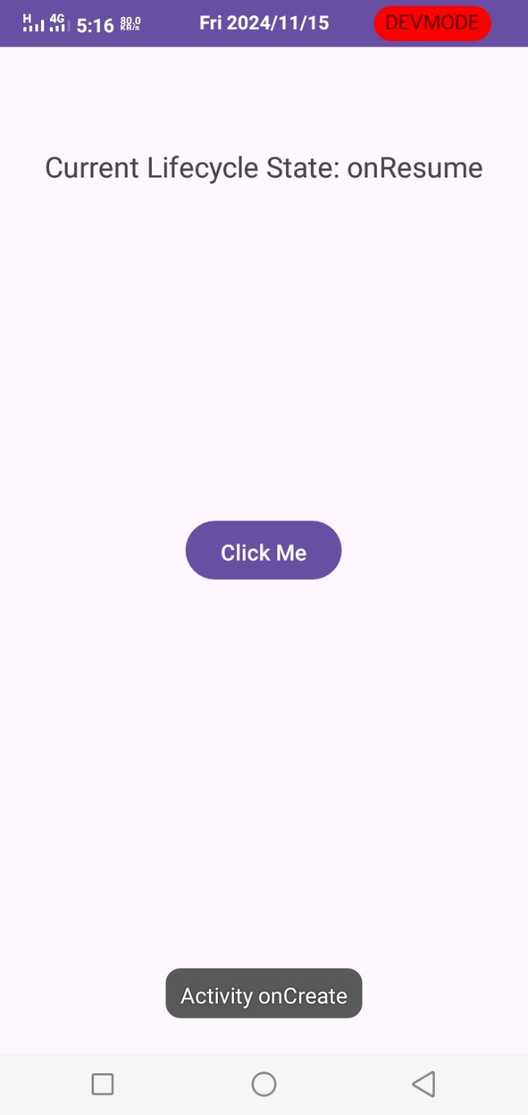

1. Create table Customer (id, name, address, ph_no). Create Application for performing the following operation on the table. (Using SQLite database).
2. Insert new customer details (At least records).
3. Show all the customer details

//Refer Studentdb Program 18

1. Create an Android Application to accept two numbers to calculate it’s Power and Average. Create two buttons: Power and Average. Display the appropriate result on the next activity on Button click.

//xmlFile

<?xml version="1.0" encoding="utf-8"?>

<LinearLayout xmlns:android="http://schemas.android.com/apk/res/android"

android:layout_width="match_parent"

android:layout_height="match_parent"

android:orientation="vertical"

android:padding="16dp"

android:gravity="center">

<EditText

android:id="@+id/numberInput1"

android:layout_width="match_parent"

android:layout_height="wrap_content"

android:hint="Enter first number"

android:inputType="numberDecimal"

android:layout_marginBottom="10dp" />

<EditText

android:id="@+id/numberInput2"

android:layout_width="match_parent"

android:layout_height="wrap_content"

android:hint="Enter second number"

android:inputType="numberDecimal"

android:layout_marginBottom="20dp" />

<Button

android:id="@+id/powerButton"

android:layout_width="wrap_content"

android:layout_height="wrap_content"

android:text="Power" />

<Button

android:id="@+id/averageButton"

android:layout_width="wrap_content"

android:layout_height="wrap_content"

android:text="Average"

android:layout_marginTop="10dp" />

</LinearLayout>

//MainActivity.java

package com.example.poweraverage;

import android.content.Intent;

import android.os.Bundle;

import android.view.View;

import android.widget.Button;

import android.widget.EditText;

import android.widget.Toast;

import androidx.appcompat.app.AppCompatActivity;

public class MainActivity extends AppCompatActivity {

private EditText numberInput1, numberInput2;

private Button powerButton, averageButton;

@Override

protected void onCreate(Bundle savedInstanceState) {

super.onCreate(savedInstanceState);

setContentView(R.layout.activity_main);

numberInput1 = findViewById(R.id.numberInput1);

numberInput2 = findViewById(R.id.numberInput2);

powerButton = findViewById(R.id.powerButton);

averageButton = findViewById(R.id.averageButton);

powerButton.setOnClickListener(new View.OnClickListener() {

@Override

public void onClick(View v) {

calculate("power");

}

});

averageButton.setOnClickListener(new View.OnClickListener() {

@Override

public void onClick(View v) {

calculate("average");

}

});

}

private void calculate(String operation) {

String num1Str = numberInput1.getText().toString().trim();

String num2Str = numberInput2.getText().toString().trim();

if (num1Str.isEmpty() || num2Str.isEmpty()) {

Toast.makeText(this, "Please enter both numbers", Toast.LENGTH_SHORT).show();

return;

}

double num1 = Double.parseDouble(num1Str);

double num2 = Double.parseDouble(num2Str);

double result;

if (operation.equals("power")) {

result = Math.pow(num1, num2); // Calculate num1 raised to the power of num2

} else {

result = (num1 + num2) / 2; // Calculate the average of num1 and num2

}

// Start ResultActivity and pass the result and operation type

Intent intent = new Intent(MainActivity.this, MainActivity2.class);

intent.putExtra("RESULT", result);

intent.putExtra("OPERATION", operation);

startActivity(intent);

}

}

//Xmlfile2

<?xml version="1.0" encoding="utf-8"?>

<LinearLayout xmlns:android="http://schemas.android.com/apk/res/android"

android:layout_width="match_parent"

android:layout_height="match_parent"

android:orientation="vertical"

android:padding="16dp"

android:gravity="center">

<TextView

android:id="@+id/resultView"

android:layout_width="wrap_content"

android:layout_height="wrap_content"

android:text="Result will be displayed here"

android:textSize="18sp"

android:textColor="#000" />

</LinearLayout>

//Main_Activity2.java

package com.example.poweraverage;

import android.os.Bundle;

import android.widget.TextView;

import androidx.appcompat.app.AppCompatActivity;

public class MainActivity2 extends AppCompatActivity {

private TextView resultView;

@Override

protected void onCreate(Bundle savedInstanceState) {

super.onCreate(savedInstanceState);

setContentView(R.layout.activity_main2);

resultView = findViewById(R.id.resultView);

// Retrieve the data passed from MainActivity

double result = getIntent().getDoubleExtra("RESULT", 0);

String operation = getIntent().getStringExtra("OPERATION");

// Display the appropriate message

String displayMessage;

if ("power".equals(operation)) {

displayMessage = "Power Result: " + result;

} else {

displayMessage = "Average Result: " + result;

}

resultView.setText(displayMessage);

}

}

//output

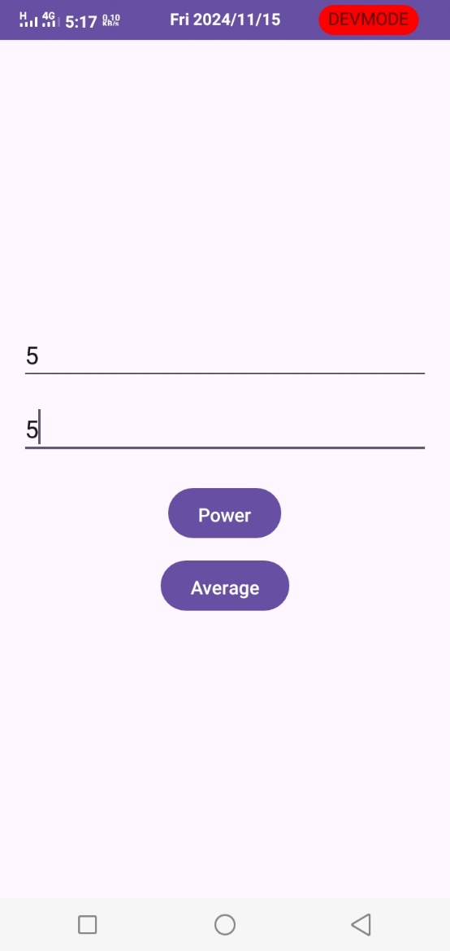

1. Create application using JSON to provide Employee Information

//XML file

<?xml version="1.0" encoding="utf-8"?>

<androidx.constraintlayout.widget.ConstraintLayout xmlns:android="http://schemas.android.com/apk/res/android"

xmlns:app="http://schemas.android.com/apk/res-auto"

xmlns:tools="http://schemas.android.com/tools"

android:id="@+id/main"

android:layout_width="match_parent"

android:layout_height="match_parent"

tools:context=".MainActivity">

<TextView

android:id="@+id/name"

android:layout_width="wrap_content"

android:layout_height="wrap_content"

android:layout_marginStart="156dp"

android:layout_marginTop="190dp"

android:layout_marginEnd="197dp"

android:layout_marginBottom="110dp"

android:text="TextView"

app:layout_constraintBottom_toTopOf="@+id/salary"

app:layout_constraintEnd_toEndOf="parent"

app:layout_constraintHorizontal_bias="0.0"

app:layout_constraintStart_toStartOf="parent"

app:layout_constraintTop_toTopOf="parent" />

<TextView

android:id="@+id/salary"

android:layout_width="wrap_content"

android:layout_height="wrap_content"

android:layout_marginStart="156dp"

android:layout_marginTop="8dp"

android:layout_marginEnd="197dp"

android:layout_marginBottom="393dp"

android:text="TextView"

app:layout_constraintBottom_toBottomOf="parent"

app:layout_constraintEnd_toEndOf="parent"

app:layout_constraintHorizontal_bias="0.0"

app:layout_constraintStart_toStartOf="parent"

app:layout_constraintTop_toBottomOf="@+id/name" />

</androidx.constraintlayout.widget.ConstraintLayout>

//MainActivity File

package com.example.json;

import android.os.Bundle;

import android.widget.TextView;

import androidx.appcompat.app.AppCompatActivity;

import org.json.JSONException;

import org.json.JSONObject;

public class MainActivity extends AppCompatActivity {

String JSON_STRING="{\"employee\":{\"name\":\"Sakshi\",\"salary\":25000}}";

String name, salary;

TextView employeeName, employeeSalary;

@Override

protected void onCreate(Bundle savedInstanceState) {

super.onCreate(savedInstanceState);

setContentView(R.layout.activity_main);

employeeName=(TextView) findViewById(R.id.name);

employeeSalary=(TextView) findViewById(R.id.salary);

try{

JSONObject obj=new JSONObject(JSON_STRING);

JSONObject employee= obj.getJSONObject("employee");

name=employee.getString("name");

salary=employee.getString("salary");

employeeName.setText("Name :"+name);

employeeSalary.setText("Salary: "+salary);

}

catch (JSONException e){

e.printStackTrace();

}

}

}

//output

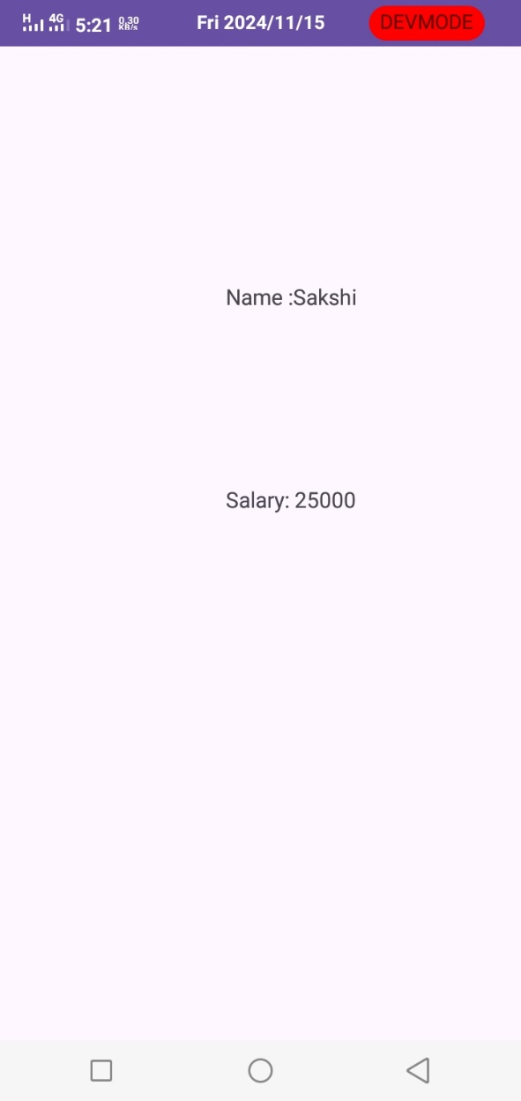

1. Construct an Android application to accept a number and calculate Armstrong and Perfect number of a given number.

//XMLFile

<?xml version="1.0" encoding="utf-8"?>

<LinearLayout xmlns:android="http://schemas.android.com/apk/res/android"

android:layout_width="match_parent"

android:layout_height="match_parent"

android:orientation="vertical"

android:padding="16dp">

<!-- EditText for entering number -->

<EditText

android:id="@+id/editTextNumber"

android:layout_width="match_parent"

android:layout_height="wrap_content"

android:hint="Enter a number"

android:inputType="number"/>

<!-- Button to check Armstrong -->

<Button

android:id="@+id/checkArmstrongButton"

android:layout_width="wrap_content"

android:layout_height="wrap_content"

android:text="Check Armstrong"

android:layout_marginTop="20dp"/>

<!-- Button to check Perfect number -->

<Button

android:id="@+id/checkPerfectButton"

android:layout_width="wrap_content"

android:layout_height="wrap_content"

android:text="Check Perfect Number"

android:layout_marginTop="20dp"/>

<!-- TextView to display results -->

<TextView

android:id="@+id/resultTextView"

android:layout_width="wrap_content"

android:layout_height="wrap_content"

android:text=""

android:textSize="18sp"

android:layout_marginTop="20dp"/>

</LinearLayout>

//MainActivity

package com.example.armstrong;

import android.os.Bundle;

import android.view.View;

import android.widget.Button;

import android.widget.EditText;

import android.widget.TextView;

import androidx.appcompat.app.AppCompatActivity;

public class MainActivity extends AppCompatActivity {

private EditText editTextNumber;

private Button checkArmstrongButton, checkPerfectButton;

private TextView resultTextView;

@Override

protected void onCreate(Bundle savedInstanceState) {

super.onCreate(savedInstanceState);

setContentView(R.layout.activity_main);

editTextNumber = findViewById(R.id.editTextNumber);

checkArmstrongButton = findViewById(R.id.checkArmstrongButton);

checkPerfectButton = findViewById(R.id.checkPerfectButton);

resultTextView = findViewById(R.id.resultTextView);

// Check for Armstrong number

checkArmstrongButton.setOnClickListener(v -> {

String input = editTextNumber.getText().toString();

if (!input.isEmpty()) {

int number = Integer.parseInt(input);

if (isArmstrong(number)) {

resultTextView.setText(number + " is an Armstrong number.");

} else {

resultTextView.setText(number + " is NOT an Armstrong number.");

}

}

});

// Check for Perfect number

checkPerfectButton.setOnClickListener(v -> {

String input = editTextNumber.getText().toString();

if (!input.isEmpty()) {

int number = Integer.parseInt(input);

if (isPerfect(number)) {

resultTextView.setText(number + " is a Perfect number.");

} else {

resultTextView.setText(number + " is NOT a Perfect number.");

}

}

});

}

// Function to check if a number is Armstrong

private boolean isArmstrong(int number) {

int sum = 0, temp, remainder, digits = 0;

temp = number;

// Calculate the number of digits

while (temp != 0) {

temp /= 10;

digits++;

}

temp = number;

// Calculate the sum of powers of digits

while (temp != 0) {

remainder = temp % 10;

sum += Math.pow(remainder, digits);

temp /= 10;

}

return sum == number;

}

// Function to check if a number is Perfect

private boolean isPerfect(int number) {

int sum = 0;

// Calculate the sum of divisors

for (int i = 1; i <= number / 2; i++) {

if (number % i == 0) {

sum += i;

}

}

return sum == number;

}

}

//output

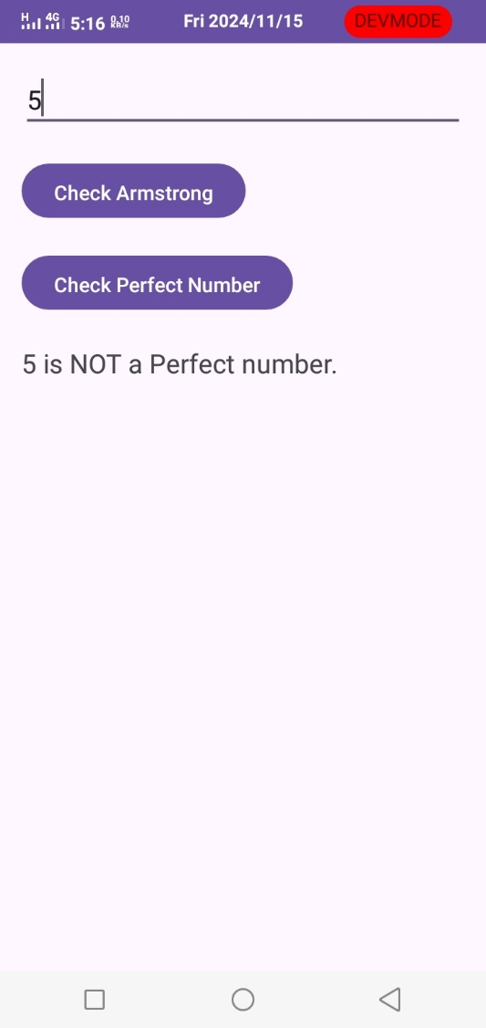

1. Write a Java Android Program to Demonstrate List View Activity with all operations

Such as: Insert, Delete, Search

//XMLFile

<?xml version="1.0" encoding="utf-8"?>

<LinearLayout xmlns:android="http://schemas.android.com/apk/res/android"

android:layout_width="match_parent"

android:layout_height="match_parent"

android:orientation="vertical"

android:padding="16dp">

<!-- EditText to input new item -->

<EditText

android:id="@+id/editText"

android:layout_width="match_parent"

android:layout_height="wrap_content"

android:hint="Enter item"

android:inputType="text"/>

<!-- Buttons for operations -->

<LinearLayout

android:orientation="horizontal"

android:layout_width="match_parent"

android:layout_height="wrap_content"

android:gravity="center">

<Button

android:id="@+id/insertButton"

android:layout_width="wrap_content"

android:layout_height="wrap_content"

android:text="Insert" />

<Button

android:id="@+id/deleteButton"

android:layout_width="wrap_content"

android:layout_height="wrap_content"

android:text="Delete"

android:layout_marginLeft="10dp"/>

<Button

android:id="@+id/searchButton"

android:layout_width="wrap_content"

android:layout_height="wrap_content"

android:text="Search"

android:layout_marginLeft="10dp"/>

</LinearLayout>

<!-- ListView to display items -->

<ListView

android:id="@+id/listView"

android:layout_width="match_parent"

android:layout_height="0dp"

android:layout_weight="1"/>

</LinearLayout>

//MainActivity

package com.example.listview;

import android.os.Bundle;

import android.view.View;

import android.widget.ArrayAdapter;

import android.widget.Button;

import android.widget.EditText;

import android.widget.ListView;

import android.widget.Toast;

import androidx.appcompat.app.AppCompatActivity;

import java.util.ArrayList;

public class MainActivity extends AppCompatActivity {

private EditText editText;

private Button insertButton, deleteButton, searchButton;

private ListView listView;

private ArrayList<String> itemList;

private ArrayAdapter<String> adapter;

@Override

protected void onCreate(Bundle savedInstanceState) {

super.onCreate(savedInstanceState);

setContentView(R.layout.activity_main);

editText = findViewById(R.id.editText);

insertButton = findViewById(R.id.insertButton);

deleteButton = findViewById(R.id.deleteButton);

searchButton = findViewById(R.id.searchButton);

listView = findViewById(R.id.listView);

// Initialize item list and set up adapter

itemList = new ArrayList<>();

adapter = new ArrayAdapter<>(this, android.R.layout.simple_list_item_1, itemList);

listView.setAdapter(adapter);

// Insert button listener

insertButton.setOnClickListener(v -> {

String item = editText.getText().toString();

if (!item.isEmpty()) {

itemList.add(item);

adapter.notifyDataSetChanged();

editText.setText("");

Toast.makeText(MainActivity.this, "Item Inserted", Toast.LENGTH_SHORT).show();

} else {

Toast.makeText(MainActivity.this, "Please enter an item", Toast.LENGTH_SHORT).show();

}

});

// Delete button listener

deleteButton.setOnClickListener(v -> {

String itemToDelete = editText.getText().toString();

if (itemList.contains(itemToDelete)) {

itemList.remove(itemToDelete);

adapter.notifyDataSetChanged();

editText.setText("");

Toast.makeText(MainActivity.this, "Item Deleted", Toast.LENGTH_SHORT).show();

} else {

Toast.makeText(MainActivity.this, "Item not found", Toast.LENGTH_SHORT).show();

}

});

// Search button listener

searchButton.setOnClickListener(v -> {

String itemToSearch = editText.getText().toString();

if (itemList.contains(itemToSearch)) {

Toast.makeText(MainActivity.this, "Item Found", Toast.LENGTH_SHORT).show();

} else {

Toast.makeText(MainActivity.this, "Item Not Found", Toast.LENGTH_SHORT).show();

}

});

}

}

//output

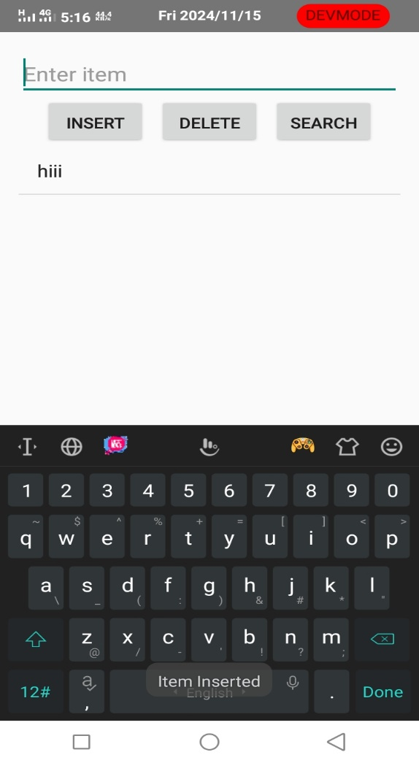

1. Create an application to demonstrate login form with validation.

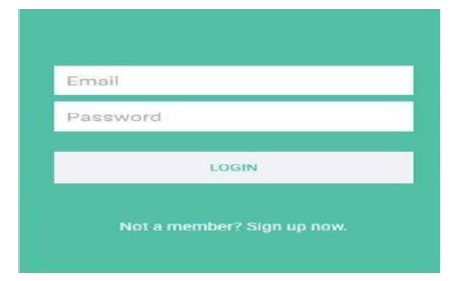

//xmlFile

<?xml version="1.0" encoding="utf-8"?>

<LinearLayout xmlns:android="http://schemas.android.com/apk/res/android"

android:layout_width="match_parent"

android:layout_height="match_parent"

android:orientation="vertical"

android:padding="16dp"

android:gravity="center"

android:background="#4cafaf">

<EditText

android:id="@+id/emailInput"

android:layout_width="match_parent"

android:layout_height="wrap_content"

android:hint="Email"

android:inputType="textEmailAddress"

android:background="#FFFFFF"

android:padding="10dp"

android:layout_marginBottom="10dp" />

<EditText

android:id="@+id/passwordInput"

android:layout_width="match_parent"

android:layout_height="wrap_content"

android:hint="Password"

android:inputType="textPassword"

android:background="#FFFFFF"

android:padding="10dp"

android:layout_marginBottom="20dp" />

<Button

android:id="@+id/loginButton"

android:layout_width="match_parent"

android:layout_height="wrap_content"

android:text="LOGIN"

android:background="#FFFFFF"

android:textColor="#4cafaf" />

<TextView

android:id="@+id/signupPrompt"

android:layout_width="wrap_content"

android:layout_height="wrap_content"

android:text="Not a member? Sign up now."

android:textColor="#FFFFFF"

android:layout_marginTop="20dp" />

</LinearLayout>

//MainActivity

package com.example.loginform1;

import android.os.Bundle;

import android.text.TextUtils;

import android.util.Patterns;

import android.view.View;

import android.widget.Button;

import android.widget.EditText;

import android.widget.TextView;

import android.widget.Toast;

import androidx.appcompat.app.AppCompatActivity;

public class MainActivity extends AppCompatActivity {

private EditText emailInput, passwordInput;

private Button loginButton;

private TextView signupPrompt;

@Override

protected void onCreate(Bundle savedInstanceState) {

super.onCreate(savedInstanceState);

setContentView(R.layout.activity_main);

emailInput = findViewById(R.id.emailInput);

passwordInput = findViewById(R.id.passwordInput);

loginButton = findViewById(R.id.loginButton);

signupPrompt = findViewById(R.id.signupPrompt);

loginButton.setOnClickListener(new View.OnClickListener() {

@Override

public void onClick(View v) {

validateInput();

}

});

signupPrompt.setOnClickListener(new View.OnClickListener() {

@Override

public void onClick(View v) {

Toast.makeText(MainActivity.this, "Signup option clicked!", Toast.LENGTH_SHORT).show();

// You can start a new activity for signup here if needed.

}

});

}

private void validateInput() {

String email = emailInput.getText().toString().trim();

String password = passwordInput.getText().toString().trim();

if (TextUtils.isEmpty(email)) {

emailInput.setError("Email is required");

emailInput.requestFocus();

} else if (!Patterns.EMAIL_ADDRESS.matcher(email).matches()) {

emailInput.setError("Enter a valid email");

emailInput.requestFocus();

} else if (TextUtils.isEmpty(password)) {

passwordInput.setError("Password is required");

passwordInput.requestFocus();

} else {

Toast.makeText(this, "Login successful", Toast.LENGTH_SHORT).show();

// Proceed with login logic, e.g., authenticate with backend.

}

}

}

//output

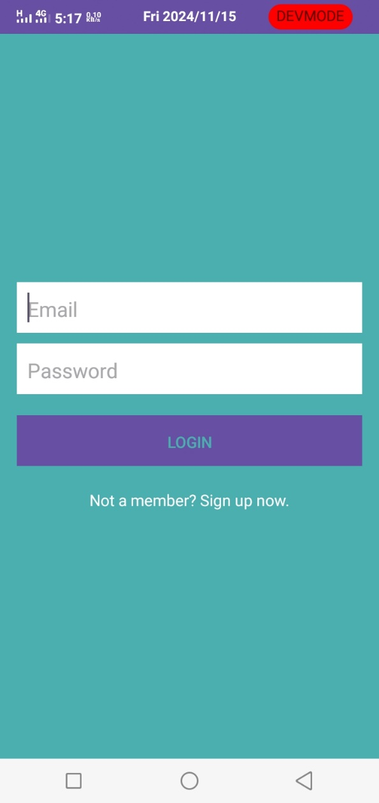

1. Create an application Which reads the person greet message from one activity and display the Greet message on another activity on click of Button (Use Intent).

//XmlFile

<?xml version="1.0" encoding="utf-8"?>

<LinearLayout xmlns:android="http://schemas.android.com/apk/res/android"

android:layout_width="match_parent"

android:layout_height="match_parent"

xmlns:tools="http://schemas.android.com/tools"

android:orientation="vertical"

android:layout_gravity="center">

<EditText

android:id="@+id/greetmessage"

android:layout_width="match_parent"

android:layout_height="74dp"

android:layout_margin="50dp"

android:hint="enter Greet message" />

<Button

android:id= "@+id/clickme"

android:layout_width="wrap_content"

android:layout_height="wrap_content"

android:layout_marginTop="50dp"

android:layout_marginLeft="60dp"

android:text="Click me" />

</LinearLayout>

//MainActivity

package com.example.greet;

import android.content.Intent;

import android.os.Bundle;

import android.view.View;

import android.widget.Button;

import android.widget.EditText;

import android.widget.TextView;

import androidx.activity.EdgeToEdge;

import androidx.appcompat.app.AppCompatActivity;

import androidx.core.graphics.Insets;

import androidx.core.view.ViewCompat;

import androidx.core.view.WindowInsetsCompat;

public class MainActivity extends AppCompatActivity {

private EditText greetmessage;

private Button clickme;

@Override

protected void onCreate(Bundle savedInstanceState) {

super.onCreate(savedInstanceState);

setContentView(R.layout.activity_main);

greetmessage = findViewById(R.id.greetmessage);

clickme = findViewById(R.id.clickme);

clickme.setOnClickListener(new View.OnClickListener() {

@Override

public void onClick(View v) {

String grt = greetmessage.getText().toString();

Intent i = new Intent(MainActivity.this, ResultActivity.class);

i.putExtra("greeting_message", grt);

startActivity(i);

}

}

);

}

}

//xmlfile2

<?xml version="1.0" encoding="utf-8"?>

<LinearLayout xmlns:android="http://schemas.android.com/apk/res/android"

android:layout_width="match_parent"

android:layout_height="match_parent"

android:orientation="vertical"

android:layout_gravity="center">

<TextView

android:layout_width="match_parent"

android:layout_height="wrap_content"

android:id="@+id/message"

android:text="Greeting will be displayed here"

android:layout_marginTop="16dp"

/>

</LinearLayout>

//MainActivity2

package com.example.greet;

import android.content.Intent;

import android.os.Bundle;

import android.view.View;

import android.widget.Button;

import android.widget.TextView;

import androidx.activity.EdgeToEdge;

import androidx.appcompat.app.AppCompatActivity;

public class ResultActivity extends AppCompatActivity {

private TextView message;

@Override

protected void onCreate(Bundle savedInstanceState) {

super.onCreate(savedInstanceState);

setContentView(R.layout.activity_result);

message = findViewById(R.id.message);

String result = getIntent().getStringExtra("greeting_message");

message.setText(result);

}

}

1. Create an application to change Font Size, Color and Font Family of String.

//XMLFile

<?xml version="1.0" encoding="utf-8"?>

<LinearLayout xmlns:android="http://schemas.android.com/apk/res/android"

android:layout_width="match_parent"

android:layout_height="match_parent"

android:orientation="vertical"

android:padding="16dp">

<TextView

android:id="@+id/sampleText"

android:layout_width="wrap_content"

android:layout_height="wrap_content"

android:text="Sample Text"

android:textSize="18sp"

android:layout_gravity="center_horizontal"

android:padding="16dp"/>

<TextView

android:layout_width="wrap_content"

android:layout_height="wrap_content"

android:paddingTop="16dp"

android:text="Adjust Font Size" />

<SeekBar

android:id="@+id/sizeSeekBar"

android:layout_width="match_parent"

android:layout_height="wrap_content"/>

<TextView

android:layout_width="wrap_content"

android:layout_height="wrap_content"

android:text="Adjust Font Color"

android:paddingTop="16dp"/>

<SeekBar

android:id="@+id/colorSeekBar"

android:layout_width="match_parent"

android:layout_height="wrap_content"/>

<TextView

android:layout_width="wrap_content"

android:layout_height="wrap_content"

android:paddingTop="16dp"

android:text="Select Font Family" />

<Spinner

android:id="@+id/fontSpinner"

android:layout_width="match_parent"

android:layout_height="81dp" />

</LinearLayout>

//MainActivity

package com.example.fontchanger;

import android.graphics.Color;

import android.os.Bundle;

import android.view.View;

import android.widget.AdapterView;

import android.widget.ArrayAdapter;

import android.widget.SeekBar;

import android.widget.Spinner;

import android.widget.TextView;

import androidx.appcompat.app.AppCompatActivity;

public class MainActivity extends AppCompatActivity {

private TextView sampleText;

private SeekBar sizeSeekBar, colorSeekBar;

private Spinner fontSpinner;

@Override

protected void onCreate(Bundle savedInstanceState) {

super.onCreate(savedInstanceState);

setContentView(R.layout.activity_main);

sampleText = findViewById(R.id.sampleText);

sizeSeekBar = findViewById(R.id.sizeSeekBar);

colorSeekBar = findViewById(R.id.colorSeekBar);

fontSpinner = findViewById(R.id.fontSpinner);

// Initialize SeekBar for font size

sizeSeekBar.setMax(50);

sizeSeekBar.setProgress(14); // Default font size

sizeSeekBar.setOnSeekBarChangeListener(new SeekBar.OnSeekBarChangeListener() {

@Override

public void onProgressChanged(SeekBar seekBar, int progress, boolean fromUser) {

sampleText.setTextSize(progress);

}

@Override

public void onStartTrackingTouch(SeekBar seekBar) {}

@Override

public void onStopTrackingTouch(SeekBar seekBar) {}

});

// Initialize SeekBar for font color

colorSeekBar.setMax(255);

colorSeekBar.setProgress(0); // Default color (black)

colorSeekBar.setOnSeekBarChangeListener(new SeekBar.OnSeekBarChangeListener() {

@Override

public void onProgressChanged(SeekBar seekBar, int progress, boolean fromUser) {

sampleText.setTextColor(Color.rgb(progress, 0, 255 - progress));

}

@Override

public void onStartTrackingTouch(SeekBar seekBar) {}

@Override

public void onStopTrackingTouch(SeekBar seekBar) {}

});

// Initialize Spinner for font family

String[] fontFamilies = {"sans-serif", "serif", "monospace"};

ArrayAdapter<String> adapter = new ArrayAdapter<>(this, android.R.layout.simple_spinner_item, fontFamilies);

adapter.setDropDownViewResource(android.R.layout.simple_spinner_dropdown_item);

fontSpinner.setAdapter(adapter);

fontSpinner.setOnItemSelectedListener(new AdapterView.OnItemSelectedListener() {

@Override

public void onItemSelected(AdapterView<?> parent, View view, int position, long id) {

String selectedFont = fontFamilies[position];

sampleText.setTypeface(android.graphics.Typeface.create(selectedFont, android.graphics.Typeface.NORMAL));

}

@Override

public void onNothingSelected(AdapterView<?> parent) {}

});

}

}

//output

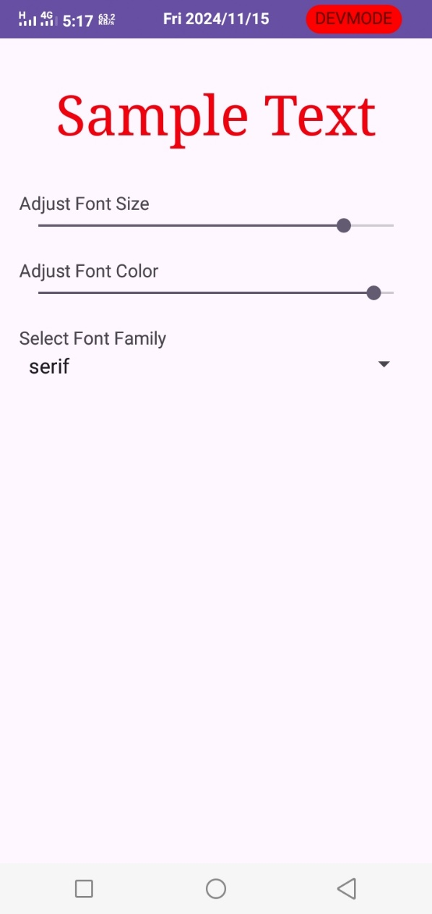

1. Create an application for registration form given below. Also perform appropriate validation.

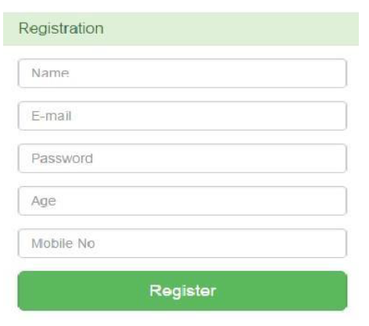

//xmlfile

<?xml version="1.0" encoding="utf-8"?>

<LinearLayout xmlns:android="http://schemas.android.com/apk/res/android"

android:layout_width="match_parent"

android:layout_height="match_parent"

android:orientation="vertical"

android:padding="16dp"

android:gravity="center"

android:background="#E8F5E9">

<TextView

android:layout_width="wrap_content"

android:layout_height="wrap_content"

android:text="Registration"

android:textSize="24sp"

android:textColor="#4CAF50"

android:layout_marginBottom="20dp" />

<EditText

android:id="@+id/nameInput"

android:layout_width="match_parent"

android:layout_height="wrap_content"

android:hint="Name"

android:layout_marginBottom="10dp"

android:background="#FFFFFF" />

<EditText

android:id="@+id/emailInput"

android:layout_width="match_parent"

android:layout_height="wrap_content"

android:hint="E-mail"

android:inputType="textEmailAddress"

android:layout_marginBottom="10dp"

android:background="#FFFFFF" />

<EditText

android:id="@+id/passwordInput"

android:layout_width="match_parent"

android:layout_height="wrap_content"

android:hint="Password"

android:inputType="textPassword"

android:layout_marginBottom="10dp"

android:background="#FFFFFF" />

<EditText

android:id="@+id/ageInput"

android:layout_width="match_parent"

android:layout_height="wrap_content"

android:hint="Age"

android:inputType="number"

android:layout_marginBottom="10dp"

android:background="#FFFFFF" />

<EditText

android:id="@+id/mobileInput"

android:layout_width="match_parent"

android:layout_height="wrap_content"

android:hint="Mobile No"

android:inputType="phone"

android:layout_marginBottom="20dp"

android:background="#FFFFFF" />

<Button

android:id="@+id/registerButton"

android:layout_width="wrap_content"

android:layout_height="wrap_content"

android:text="Register"

android:background="#4CAF50"

android:textColor="#FFFFFF" />

</LinearLayout>

//MainActivity

package com.example.registrationform;

import android.os.Bundle;

import android.text.TextUtils;

import android.util.Patterns;

import android.view.View;

import android.widget.Button;

import android.widget.EditText;

import android.widget.Toast;

import androidx.appcompat.app.AppCompatActivity;

public class MainActivity extends AppCompatActivity {

private EditText nameInput, emailInput, passwordInput, ageInput, mobileInput;

private Button registerButton;

@Override

protected void onCreate(Bundle savedInstanceState) {

super.onCreate(savedInstanceState);

setContentView(R.layout.activity_main);

nameInput = findViewById(R.id.nameInput);

emailInput = findViewById(R.id.emailInput);

passwordInput = findViewById(R.id.passwordInput);

ageInput = findViewById(R.id.ageInput);

mobileInput = findViewById(R.id.mobileInput);

registerButton = findViewById(R.id.registerButton);

registerButton.setOnClickListener(new View.OnClickListener() {

@Override

public void onClick(View v) {

validateAndRegister();

}

});

}

private void validateAndRegister() {

String name = nameInput.getText().toString().trim();

String email = emailInput.getText().toString().trim();

String password = passwordInput.getText().toString().trim();

String ageStr = ageInput.getText().toString().trim();

String mobile = mobileInput.getText().toString().trim();

if (TextUtils.isEmpty(name)) {

nameInput.setError("Name is required");

nameInput.requestFocus();

return;

}

if (TextUtils.isEmpty(email) || !Patterns.EMAIL_ADDRESS.matcher(email).matches()) {

emailInput.setError("Enter a valid email");

emailInput.requestFocus();

return;

}

if (TextUtils.isEmpty(password) || password.length() < 6) {

passwordInput.setError("Password must be at least 6 characters");

passwordInput.requestFocus();

return;

}

int age;

try {

age = Integer.parseInt(ageStr);

if (age < 18 || age > 100) {

ageInput.setError("Enter a valid age (18-100)");

ageInput.requestFocus();

return;

}

} catch (NumberFormatException e) {

ageInput.setError("Enter a valid age");

ageInput.requestFocus();

return;

}

if (TextUtils.isEmpty(mobile) || mobile.length() != 10 || !TextUtils.isDigitsOnly(mobile)) {

mobileInput.setError("Enter a valid 10-digit mobile number");

mobileInput.requestFocus();

return;

}

Toast.makeText(this, "Registration Successful", Toast.LENGTH_SHORT).show();

}

}

//OutPut

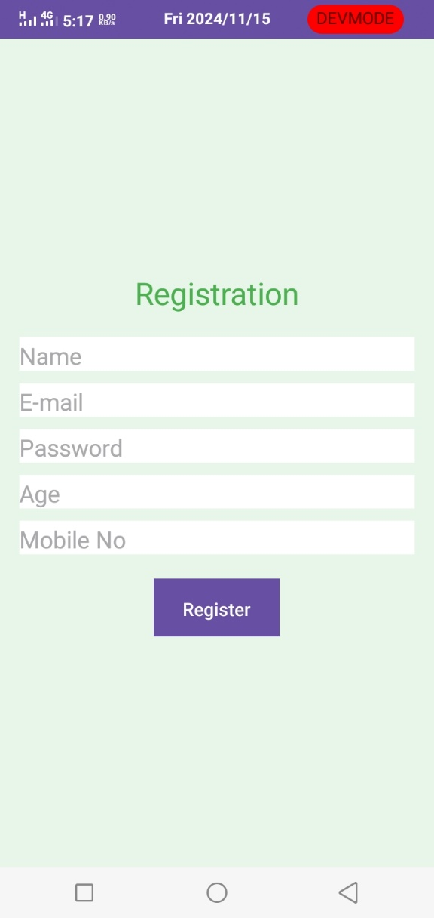

1. Create an Android Application to accept a number and display the multiplication table (Use table Layout).

//xmlFile

<?xml version="1.0" encoding="utf-8"?>

<LinearLayout xmlns:android="http://schemas.android.com/apk/res/android"

android:layout_width="match_parent"

android:layout_height="match_parent"

android:orientation="vertical"

android:padding="16dp">

<!-- Input field for the number -->

<EditText

android:id="@+id/inputNumber"

android:layout_width="match_parent"

android:layout_height="57dp"

android:hint="Enter a number"

android:inputType="number"

android:padding="10dp"

android:textSize="18sp" />

<!-- Button to generate the multiplication table -->

<Button

android:id="@+id/generateButton"

android:layout_width="wrap_content"

android:layout_height="wrap_content"

android:layout_gravity="center_horizontal"

android:layout_marginTop="16dp"

android:text="Generate Table"

android:textSize="18sp" />

<!-- TableLayout to display the multiplication table -->

<TableLayout

android:id="@+id/tableLayout"

android:layout_width="match_parent"

android:layout_height="wrap_content"

android:layout_marginTop="20dp"

android:stretchColumns="1" />

</LinearLayout>

//MainActivity

package com.example.multiplication;

import androidx.appcompat.app.AppCompatActivity;

import android.os.Bundle;

import android.text.TextUtils;

import android.view.View;

import android.widget.Button;

import android.widget.EditText;

import android.widget.TableLayout;

import android.widget.TableRow;

import android.widget.TextView;

import android.widget.Toast;

public class MainActivity extends AppCompatActivity {

EditText inputNumber;

Button generateButton;

TableLayout tableLayout;

@Override

protected void onCreate(Bundle savedInstanceState) {

super.onCreate(savedInstanceState);

setContentView(R.layout.activity_main);

inputNumber = findViewById(R.id.inputNumber);

generateButton = findViewById(R.id.generateButton);

tableLayout = findViewById(R.id.tableLayout);

generateButton.setOnClickListener(new View.OnClickListener() {

@Override

public void onClick(View v) {

generateTable();

}

});

}

private void generateTable() {

// Clear any existing table rows

tableLayout.removeAllViews();

// Get the input number

String input = inputNumber.getText().toString();

if (TextUtils.isEmpty(input)) {

Toast.makeText(this, "Please enter a number", Toast.LENGTH_SHORT).show();

return;

}

int number = Integer.parseInt(input);

// Generate and display the multiplication table

for (int i = 1; i <= 10; i++) {

TableRow row = new TableRow(this);

TextView tvMultiplier = new TextView(this);

tvMultiplier.setText(String.valueOf(number));

tvMultiplier.setPadding(8, 8, 8, 8);

TextView tvOperator = new TextView(this);

tvOperator.setText("x");

tvOperator.setPadding(8, 8, 8, 8);

TextView tvTimes = new TextView(this);

tvTimes.setText(String.valueOf(i));

tvTimes.setPadding(8, 8, 8, 8);

TextView tvEquals = new TextView(this);

tvEquals.setText("=");

tvEquals.setPadding(8, 8, 8, 8);

TextView tvResult = new TextView(this);

tvResult.setText(String.valueOf(number * i));

tvResult.setPadding(8, 8, 8, 8);

// Add the TextViews to the row

row.addView(tvMultiplier);

row.addView(tvOperator);

row.addView(tvTimes);

row.addView(tvEquals);

row.addView(tvResult);

// Add the row to the table layout

tableLayout.addView(row);

}

}

}

//OutPut

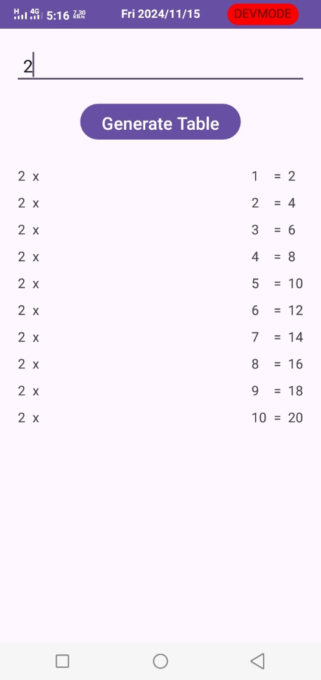

1. Create table Student (id, name, address, phno). Create Application for performing the following operation on the table.

i) Insert New Student Details.

ii) Show All the Students Details.

//XmlFile

<?xml version="1.0" encoding="utf-8"?>

<LinearLayout xmlns:android="http://schemas.android.com/apk/res/android"

android:layout_width="match_parent"

android:layout_height="match_parent"

android:orientation="vertical"

android:padding="16dp">

<EditText

android:id="@+id/rollnoInput"

android:layout_width="match_parent"

android:layout_height="wrap_content"

android:hint="Roll No"

android:inputType="number" />

<EditText

android:id="@+id/nameInput"

android:layout_width="match_parent"

android:layout_height="wrap_content"

android:hint="Name"

android:inputType="textPersonName" />

<EditText

android:id="@+id/classInput"

android:layout_width="match_parent"

android:layout_height="wrap_content"

android:hint="Class"

android:inputType="text" />

<EditText

android:id="@+id/contactInput"

android:layout_width="match_parent"

android:layout_height="wrap_content"

android:hint="Contact"

android:inputType="phone" />

<Button

android:id="@+id/insertButton"

android:layout_width="wrap_content"

android:layout_height="wrap_content"

android:text="Insert" />

<Button

android:id="@+id/displayButton"

android:layout_width="wrap_content"

android:layout_height="wrap_content"

android:text="Display"

android:layout_marginTop="10dp" />

<TextView

android:id="@+id/displayText"

android:layout_width="match_parent"

android:layout_height="wrap_content"

android:text="Display data here"

android:layout_marginTop="20dp" />

</LinearLayout>

//MainActivity

package com.example.studentdb;

import android.database.Cursor;

import android.os.Bundle;

import android.view.View;

import android.widget.Button;

import android.widget.EditText;

import android.widget.TextView;

import android.widget.Toast;

import androidx.appcompat.app.AppCompatActivity;

public class MainActivity extends AppCompatActivity {

private EditText rollnoInput, nameInput, classInput, contactInput;

private Button insertButton, displayButton;

private TextView displayText;

private DatabaseHelper dbHelper;

@Override

protected void onCreate(Bundle savedInstanceState) {

super.onCreate(savedInstanceState);

setContentView(R.layout.activity_main);

dbHelper = new DatabaseHelper(this);

rollnoInput = findViewById(R.id.rollnoInput);

nameInput = findViewById(R.id.nameInput);

classInput = findViewById(R.id.classInput);

contactInput = findViewById(R.id.contactInput);

insertButton = findViewById(R.id.insertButton);

displayButton = findViewById(R.id.displayButton);

displayText = findViewById(R.id.displayText);

insertButton.setOnClickListener(new View.OnClickListener() {

@Override

public void onClick(View v) {

insertData();

}

});

displayButton.setOnClickListener(new View.OnClickListener() {

@Override

public void onClick(View v) {

displayData();

}

});

}

private void insertData() {

int rollno = Integer.parseInt(rollnoInput.getText().toString());

String name = nameInput.getText().toString();

String className = classInput.getText().toString();

String contact = contactInput.getText().toString();

boolean isInserted = dbHelper.insertData(rollno, name, className, contact);

if (isInserted) {

Toast.makeText(this, "Data Inserted", Toast.LENGTH_SHORT).show();

clearFields();

} else {

Toast.makeText(this, "Error Inserting Data", Toast.LENGTH_SHORT).show();

}

}

private void displayData() {

Cursor cursor = dbHelper.getAllData();

if (cursor.getCount() == 0) {

displayText.setText("No data found");

return;

}

StringBuilder builder = new StringBuilder();

while (cursor.moveToNext()) {

builder.append("Roll No: ").append(cursor.getInt(0)).append("\n");

builder.append("Name: ").append(cursor.getString(1)).append("\n");

builder.append("Class: ").append(cursor.getString(2)).append("\n");

builder.append("Contact: ").append(cursor.getString(3)).append("\n\n");

}

displayText.setText(builder.toString());

}

private void clearFields() {

rollnoInput.setText("");

nameInput.setText("");

classInput.setText("");

contactInput.setText("");

}

}

//DatabaseHelper

package com.example.studentdb;

import android.content.ContentValues;

import android.content.Context;

import android.database.Cursor;

import android.database.sqlite.SQLiteDatabase;

import android.database.sqlite.SQLiteOpenHelper;

public class DatabaseHelper extends SQLiteOpenHelper {

private static final String DATABASE_NAME = "student.db";

private static final String TABLE_NAME = "Student";

private static final String COL_ROLLNO = "Rollno";

private static final String COL_NAME = "Name";

private static final String COL_CLASS = "Class";

private static final String COL_CONTACT = "Contact";

public DatabaseHelper(Context context) {

super(context, DATABASE_NAME, null, 1);

}

@Override

public void onCreate(SQLiteDatabase db) {

String createTable = "CREATE TABLE " + TABLE_NAME + " (" +

COL_ROLLNO + " INTEGER PRIMARY KEY, " +

COL_NAME + " TEXT, " +

COL_CLASS + " TEXT, " +

COL_CONTACT + " TEXT)";

db.execSQL(createTable);

}

@Override

public void onUpgrade(SQLiteDatabase db, int oldVersion, int newVersion) {

db.execSQL("DROP TABLE IF EXISTS " + TABLE_NAME);

onCreate(db);

}

// Insert data into the table

public boolean insertData(int rollno, String name, String className, String contact) {

SQLiteDatabase db = this.getWritableDatabase();

ContentValues contentValues = new ContentValues();

contentValues.put(COL_ROLLNO, rollno);

contentValues.put(COL_NAME, name);

contentValues.put(COL_CLASS, className);

contentValues.put(COL_CONTACT, contact);

long result = db.insert(TABLE_NAME, null, contentValues);

return result != -1; // returns true if insertion is successful

}

// Get all data from the table

public Cursor getAllData() {

SQLiteDatabase db = this.getReadableDatabase();

return db.rawQuery("SELECT * FROM " + TABLE_NAME, null);

}

}

//Output

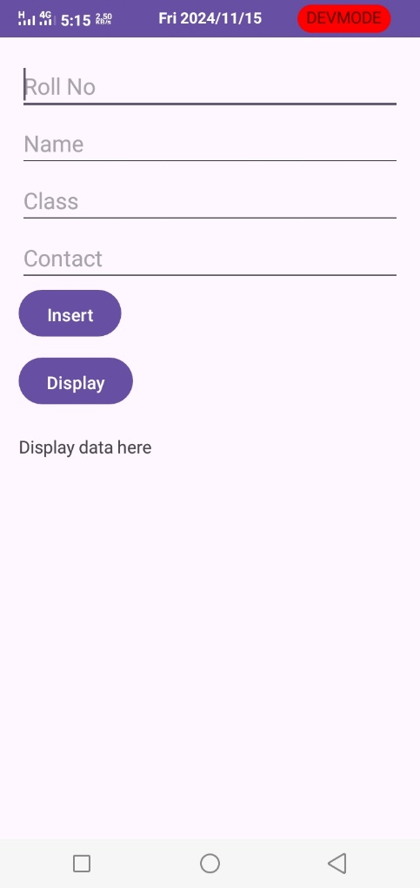

1. Create an application that Demonstrates List View and Onclick of List Display with Toast Message.

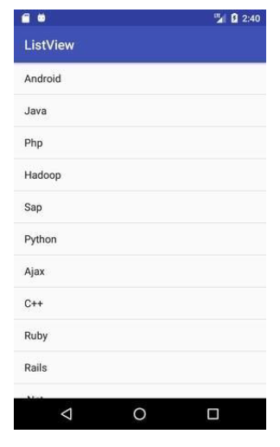

1. Create an application to send and receive messages using SMS Manager.
2. Design an application for login activity. Write android code to check login credentials with username = "mca" and password = "android". Display appropriate toast message to the user.
3. Create the simple calculator shown below also perform appropriate operation.

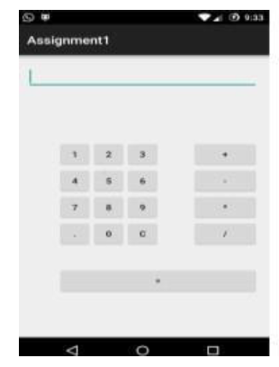

//XmlFile

<?xml version="1.0" encoding="utf-8"?>

<LinearLayout xmlns:android="http://schemas.android.com/apk/res/android"

android:layout_width="match_parent"

android:layout_height="match_parent"

android:orientation="vertical"

android:padding="16dp">

<!-- Display area for input and result -->

<EditText

android:id="@+id/display"

android:layout_width="match_parent"

android:layout_height="wrap_content"

android:gravity="right"

android:hint="0"

android:inputType="none"

android:textSize="24sp"

android:padding="10dp"

android:background="@android:color/white"

android:focusable="false" />

<!-- GridLayout for calculator buttons -->

<GridLayout

android:layout_width="match_parent"

android:layout_height="wrap_content"

android:layout_marginTop="16dp"

android:columnCount="4"

android:rowCount="5"

android:padding="5dp">

<!-- Number and operation buttons -->

<Button android:id="@+id/btn1" android:text="1" android:layout_width="0dp" android:layout_height="wrap_content" android:layout_columnWeight="1" android:textSize="24sp"/>

<Button android:id="@+id/btn2" android:text="2" android:layout_width="0dp" android:layout_height="wrap_content" android:layout_columnWeight="1" android:textSize="24sp"/>

<Button android:id="@+id/btn3" android:text="3" android:layout_width="0dp" android:layout_height="wrap_content" android:layout_columnWeight="1" android:textSize="24sp"/>

<Button android:id="@+id/btnPlus" android:text="+" android:layout_width="0dp" android:layout_height="wrap_content" android:layout_columnWeight="1" android:textSize="24sp"/>

<Button android:id="@+id/btn4" android:text="4" android:layout_width="0dp" android:layout_height="wrap_content" android:layout_columnWeight="1" android:textSize="24sp"/>

<Button android:id="@+id/btn5" android:text="5" android:layout_width="0dp" android:layout_height="wrap_content" android:layout_columnWeight="1" android:textSize="24sp"/>

<Button android:id="@+id/btn6" android:text="6" android:layout_width="0dp" android:layout_height="wrap_content" android:layout_columnWeight="1" android:textSize="24sp"/>

<Button android:id="@+id/btnMinus" android:text="-" android:layout_width="0dp" android:layout_height="wrap_content" android:layout_columnWeight="1" android:textSize="24sp"/>

<Button android:id="@+id/btn7" android:text="7" android:layout_width="0dp" android:layout_height="wrap_content" android:layout_columnWeight="1" android:textSize="24sp"/>

<Button android:id="@+id/btn8" android:text="8" android:layout_width="0dp" android:layout_height="wrap_content" android:layout_columnWeight="1" android:textSize="24sp"/>

<Button android:id="@+id/btn9" android:text="9" android:layout_width="0dp" android:layout_height="wrap_content" android:layout_columnWeight="1" android:textSize="24sp"/>

<Button android:id="@+id/btnMultiply" android:text="*" android:layout_width="0dp" android:layout_height="wrap_content" android:layout_columnWeight="1" android:textSize="24sp"/>

<Button android:id="@+id/btnClear" android:text="C" android:layout_width="0dp" android:layout_height="wrap_content" android:layout_columnWeight="1" android:textSize="24sp"/>

<Button android:id="@+id/btn0" android:text="0" android:layout_width="0dp" android:layout_height="wrap_content" android:layout_columnWeight="1" android:textSize="24sp"/>

<Button android:id="@+id/btnEqual" android:text="=" android:layout_width="0dp" android:layout_height="wrap_content" android:layout_columnWeight="1" android:textSize="24sp"/>

<Button android:id="@+id/btnDivide" android:text="/" android:layout_width="0dp" android:layout_height="wrap_content" android:layout_columnWeight="1" android:textSize="24sp"/>

</GridLayout>

</LinearLayout>

//Main Activity

package com.example.calculator;

import androidx.appcompat.app.AppCompatActivity;

import android.os.Bundle;

import android.view.View;

import android.widget.Button;

import android.widget.EditText;

import android.widget.Toast;

import com.example.calculator.R;

public class MainActivity extends AppCompatActivity {

EditText display;

double firstNumber = 0;

double secondNumber = 0;

String operator = "";

boolean isNewOperator = true;

@Override

protected void onCreate(Bundle savedInstanceState) {

super.onCreate(savedInstanceState);

setContentView(R.layout.activity_main);

display = findViewById(R.id.display);

// Setting up button click listeners

setNumberButtonListeners();

setOperatorButtonListeners();

}

private void setNumberButtonListeners() {

View.OnClickListener listener = new View.OnClickListener() {

@Override

public void onClick(View v) {

if (isNewOperator) {

display.setText("");

isNewOperator = false;

}

Button button = (Button) v;

display.append(button.getText().toString());

}

};

// Number buttons

findViewById(R.id.btn0).setOnClickListener(listener);

findViewById(R.id.btn1).setOnClickListener(listener);

findViewById(R.id.btn2).setOnClickListener(listener);

findViewById(R.id.btn3).setOnClickListener(listener);

findViewById(R.id.btn4).setOnClickListener(listener);

findViewById(R.id.btn5).setOnClickListener(listener);

findViewById(R.id.btn6).setOnClickListener(listener);

findViewById(R.id.btn7).setOnClickListener(listener);

findViewById(R.id.btn8).setOnClickListener(listener);

findViewById(R.id.btn9).setOnClickListener(listener);

}

private void setOperatorButtonListeners() {

findViewById(R.id.btnPlus).setOnClickListener(operatorListener("+"));

findViewById(R.id.btnMinus).setOnClickListener(operatorListener("-"));

findViewById(R.id.btnMultiply).setOnClickListener(operatorListener("*"));

findViewById(R.id.btnDivide).setOnClickListener(operatorListener("/"));

// Equals button to calculate the result

findViewById(R.id.btnEqual).setOnClickListener(new View.OnClickListener() {

@Override

public void onClick(View v) {

secondNumber = Double.parseDouble(display.getText().toString());

double result = calculateResult(firstNumber, secondNumber, operator);

display.setText(String.valueOf(result));

isNewOperator = true;

}

});

// Clear button

findViewById(R.id.btnClear).setOnClickListener(new View.OnClickListener() {

@Override

public void onClick(View v) {

display.setText("0");

firstNumber = 0;

secondNumber = 0;

operator = "";

isNewOperator = true;

}

});

}

private View.OnClickListener operatorListener(final String op) {

return new View.OnClickListener() {

@Override

public void onClick(View v) {

firstNumber = Double.parseDouble(display.getText().toString());

operator = op;

isNewOperator = true;

}

};

}

private double calculateResult(double num1, double num2, String op) {

switch (op) {

case "+":

return num1 + num2;

case "-":

return num1 - num2;

case "*":

return num1 * num2;

case "/":

if (num2 != 0) {

return num1 / num2;

} else {

Toast.makeText(this, "Cannot divide by zero", Toast.LENGTH_SHORT).show();

return 0;

}

default:

return 0;

}

}

}

//Output

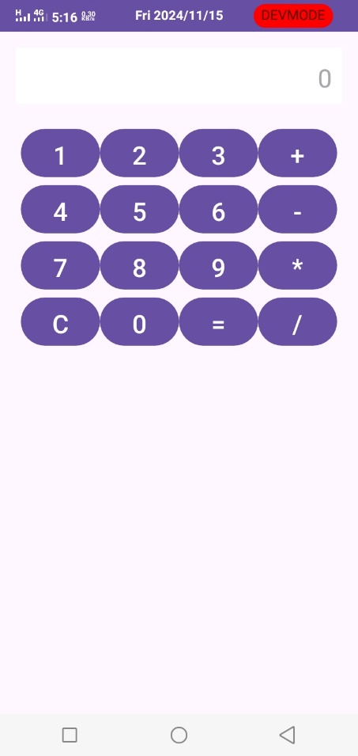

1. Create an Android Application to find the factorial of a number and Display the Result on alert box.
2. Create Table Student (Rollno, Name, Class, contact). Create an Android Application for performing the insert and display operation on the table. (Using SQLite Database).

//XmlFile

<?xml version="1.0" encoding="utf-8"?>

<LinearLayout xmlns:android="http://schemas.android.com/apk/res/android"

android:layout_width="match_parent"

android:layout_height="match_parent"

android:orientation="vertical"

android:padding="16dp">

<EditText

android:id="@+id/rollnoInput"

android:layout_width="match_parent"

android:layout_height="wrap_content"

android:hint="Roll No"

android:inputType="number" />

<EditText

android:id="@+id/nameInput"

android:layout_width="match_parent"

android:layout_height="wrap_content"

android:hint="Name"

android:inputType="textPersonName" />

<EditText

android:id="@+id/classInput"

android:layout_width="match_parent"

android:layout_height="wrap_content"

android:hint="Class"

android:inputType="text" />

<EditText

android:id="@+id/contactInput"

android:layout_width="match_parent"

android:layout_height="wrap_content"

android:hint="Contact"

android:inputType="phone" />

<Button

android:id="@+id/insertButton"

android:layout_width="wrap_content"

android:layout_height="wrap_content"

android:text="Insert" />

<Button

android:id="@+id/displayButton"

android:layout_width="wrap_content"

android:layout_height="wrap_content"

android:text="Display"

android:layout_marginTop="10dp" />

<TextView

android:id="@+id/displayText"

android:layout_width="match_parent"

android:layout_height="wrap_content"

android:text="Display data here"

android:layout_marginTop="20dp" />

</LinearLayout>

//MainActivity

package com.example.studentdb;

import android.database.Cursor;

import android.os.Bundle;

import android.view.View;

import android.widget.Button;

import android.widget.EditText;

import android.widget.TextView;

import android.widget.Toast;

import androidx.appcompat.app.AppCompatActivity;

public class MainActivity extends AppCompatActivity {

private EditText rollnoInput, nameInput, classInput, contactInput;

private Button insertButton, displayButton;

private TextView displayText;

private DatabaseHelper dbHelper;

@Override

protected void onCreate(Bundle savedInstanceState) {

super.onCreate(savedInstanceState);

setContentView(R.layout.activity_main);

dbHelper = new DatabaseHelper(this);

rollnoInput = findViewById(R.id.rollnoInput);

nameInput = findViewById(R.id.nameInput);

classInput = findViewById(R.id.classInput);

contactInput = findViewById(R.id.contactInput);

insertButton = findViewById(R.id.insertButton);

displayButton = findViewById(R.id.displayButton);

displayText = findViewById(R.id.displayText);

insertButton.setOnClickListener(new View.OnClickListener() {

@Override

public void onClick(View v) {

insertData();

}

});

displayButton.setOnClickListener(new View.OnClickListener() {

@Override

public void onClick(View v) {

displayData();

}

});

}

private void insertData() {

int rollno = Integer.parseInt(rollnoInput.getText().toString());

String name = nameInput.getText().toString();

String className = classInput.getText().toString();

String contact = contactInput.getText().toString();

boolean isInserted = dbHelper.insertData(rollno, name, className, contact);

if (isInserted) {

Toast.makeText(this, "Data Inserted", Toast.LENGTH_SHORT).show();

clearFields();

} else {

Toast.makeText(this, "Error Inserting Data", Toast.LENGTH_SHORT).show();

}

}

private void displayData() {

Cursor cursor = dbHelper.getAllData();

if (cursor.getCount() == 0) {

displayText.setText("No data found");

return;

}

StringBuilder builder = new StringBuilder();

while (cursor.moveToNext()) {

builder.append("Roll No: ").append(cursor.getInt(0)).append("\n");

builder.append("Name: ").append(cursor.getString(1)).append("\n");

builder.append("Class: ").append(cursor.getString(2)).append("\n");

builder.append("Contact: ").append(cursor.getString(3)).append("\n\n");

}

displayText.setText(builder.toString());

}

private void clearFields() {

rollnoInput.setText("");

nameInput.setText("");

classInput.setText("");

contactInput.setText("");

}

}

//DatabaseHelper

package com.example.studentdb;

import android.content.ContentValues;

import android.content.Context;

import android.database.Cursor;

import android.database.sqlite.SQLiteDatabase;

import android.database.sqlite.SQLiteOpenHelper;

public class DatabaseHelper extends SQLiteOpenHelper {

private static final String DATABASE_NAME = "student.db";

private static final String TABLE_NAME = "Student";

private static final String COL_ROLLNO = "Rollno";

private static final String COL_NAME = "Name";

private static final String COL_CLASS = "Class";

private static final String COL_CONTACT = "Contact";

public DatabaseHelper(Context context) {

super(context, DATABASE_NAME, null, 1);

}

@Override

public void onCreate(SQLiteDatabase db) {

String createTable = "CREATE TABLE " + TABLE_NAME + " (" +

COL_ROLLNO + " INTEGER PRIMARY KEY, " +

COL_NAME + " TEXT, " +

COL_CLASS + " TEXT, " +

COL_CONTACT + " TEXT)";

db.execSQL(createTable);

}

@Override

public void onUpgrade(SQLiteDatabase db, int oldVersion, int newVersion) {

db.execSQL("DROP TABLE IF EXISTS " + TABLE_NAME);

onCreate(db);

}

// Insert data into the table

public boolean insertData(int rollno, String name, String className, String contact) {

SQLiteDatabase db = this.getWritableDatabase();

ContentValues contentValues = new ContentValues();

contentValues.put(COL_ROLLNO, rollno);

contentValues.put(COL_NAME, name);

contentValues.put(COL_CLASS, className);

contentValues.put(COL_CONTACT, contact);

long result = db.insert(TABLE_NAME, null, contentValues);

return result != -1; // returns true if insertion is successful

}

// Get all data from the table

public Cursor getAllData() {

SQLiteDatabase db = this.getReadableDatabase();

return db.rawQuery("SELECT * FROM " + TABLE_NAME, null);

}

}

//output

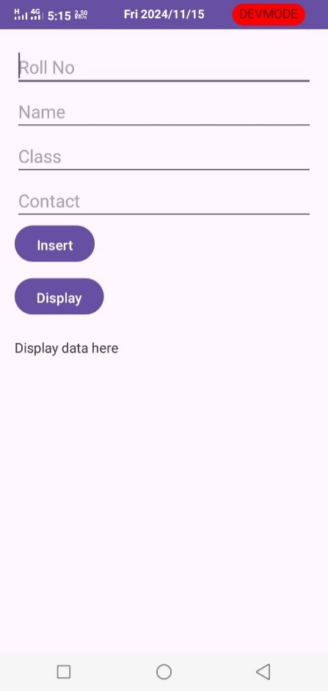

1. Create an application to find the factorial of a number and Display the Result on alert box.

//xmlfile

<?xml version="1.0" encoding="utf-8"?>

<LinearLayout xmlns:android="http://schemas.android.com/apk/res/android"

android:layout_width="match_parent"

android:layout_height="match_parent"

android:orientation="vertical"

android:padding="16dp">

<EditText

android:id="@+id/inputnumber"

android:layout_width="match_parent"

android:layout_height="172dp"

android:ems="10"

android:hint="Enter Number"

android:inputType="text" />

<Button

android:id="@+id/calculatebutton"

android:layout_width="match_parent"

android:layout_height="wrap_content"

android:text="Calculate Factorial" />

</LinearLayout>

//Main Activity

package com.example.factalert;

import androidx.appcompat.app.AlertDialog;

import androidx.appcompat.app.AppCompatActivity;

import android.os.Bundle;

import android.view.View;

import android.widget.Button;

import android.widget.EditText;

import android.widget.Toast;

public class MainActivity extends AppCompatActivity {

EditText inputNumber;

Button calculateButton;

@Override

protected void onCreate(Bundle savedInstanceState) {

super.onCreate(savedInstanceState);

setContentView(R.layout.activity_main);

inputNumber = findViewById(R.id.inputnumber);

calculateButton = findViewById(R.id.calculatebutton);

calculateButton.setOnClickListener(new View.OnClickListener() {

@Override

public void onClick(View v) {

String input = inputNumber.getText().toString();

if (!input.isEmpty()) {

int number = Integer.parseInt(input);

long factorialResult = factorial(number);

showResultDialog(number, factorialResult);

} else {

Toast.makeText(MainActivity.this, "Please enter a number", Toast.LENGTH_SHORT).show();

}

}

});

}

private long factorial(int number) {

if (number <= 1) return 1;

long result = 1;

for (int i = 2; i <= number; i++) {

result *= i;

}

return result;

}

private void showResultDialog(int number, long result) {

AlertDialog.Builder builder = new AlertDialog.Builder(this);

builder.setTitle("Factorial Result");

builder.setMessage("Factorial of " + number + " is " + result);

builder.setPositiveButton("OK", null);

builder.show();

}

}

//output

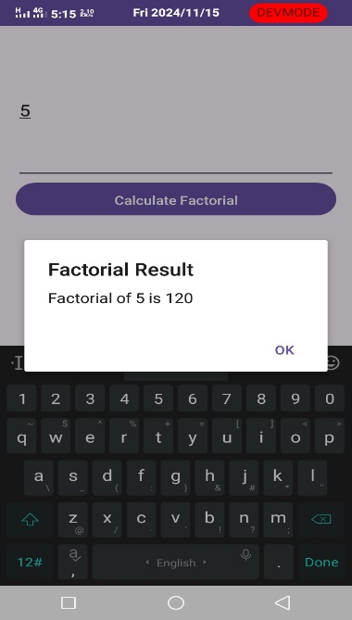

1. Construct a bank app to display different menu like withdraw, deposit etc. using ReactJS.
2. Create an application that allows the user to enter a number in the textbox. Check whether the number in the textbox is Armstrong or not. Print the message accordingly in the label control.
3. Create an application that demonstrate Options Menu, Context Menu and Popup Menu in android.
4. Create the following Vertical Scroll View Creation in Android

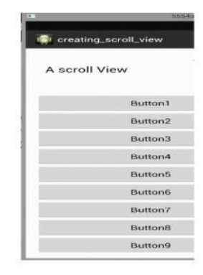

1. Create First Activity to accept information like Employee First Name, Middle Name, Last Name, Date of birth, Address, Email ID and display all information on Second Activity when user click on Submit button.
2. Create an application to accept two numbers and find power and Average. Display the result on the next activity on Button click.
3. Create an application that accept multiple items from one activity and pass to next activity and display the calculation of the first and second activity data on third.
4. Create application to send an email.
5. Construct a Login form with validation using React JS.
6. Create sample application with login module. Verify Check username and password. On successful login, pass username to next screen and if login fails, prompt the user.
7. Create Tables Employee (emp_id, emp_name, emp_desg, emp_salary) Using database perform following operation.
8. Add new record into table.
9. Accept employee name from user and display information of employee.
10. Create application to search a specific location on Google Map.
11. Create Tables Student (roll_no, name, percentage). Using database perform following operation.
12. Add new record into table.
13. Display information of students passes with first class
14. Create application to send and receive messages using SMS Manager.
15. Construct a bank app to display different menu like withdraw, deposit etc. using React JS.
16. Create a Simple Application, which reads a positive number from the user and display its factorial value in another activity.
17. Create a simple To-Do List Application using React JS.
18. Create an Android Application to accept two numbers and find power and Average. Display the result on the next activity on Button click.
19. Create an Android application to perform following operations on table Student (Sid, Sname ,phno). Use autoincrement for Sid and Perform following Operations.

i) Add Student and display its information.

ii) Delete Student

1. Create an Android Application that Demonstrate Radio Button.
2. Write a program to find the specific location of an Android device and display details of the place like Address line, city with Geocoding.
3. Create an Android Application that Demonstrate Switch and Toggle Button.
4. Create application using JSON to provide Employee information.
5. Create a custom "Contact" layout to hold multiple pieces of information, including: Photo, Name, Contact Number, E-mail id.
6. Create an application to demonstrate date and time picker.